I2202275 Current Product Development

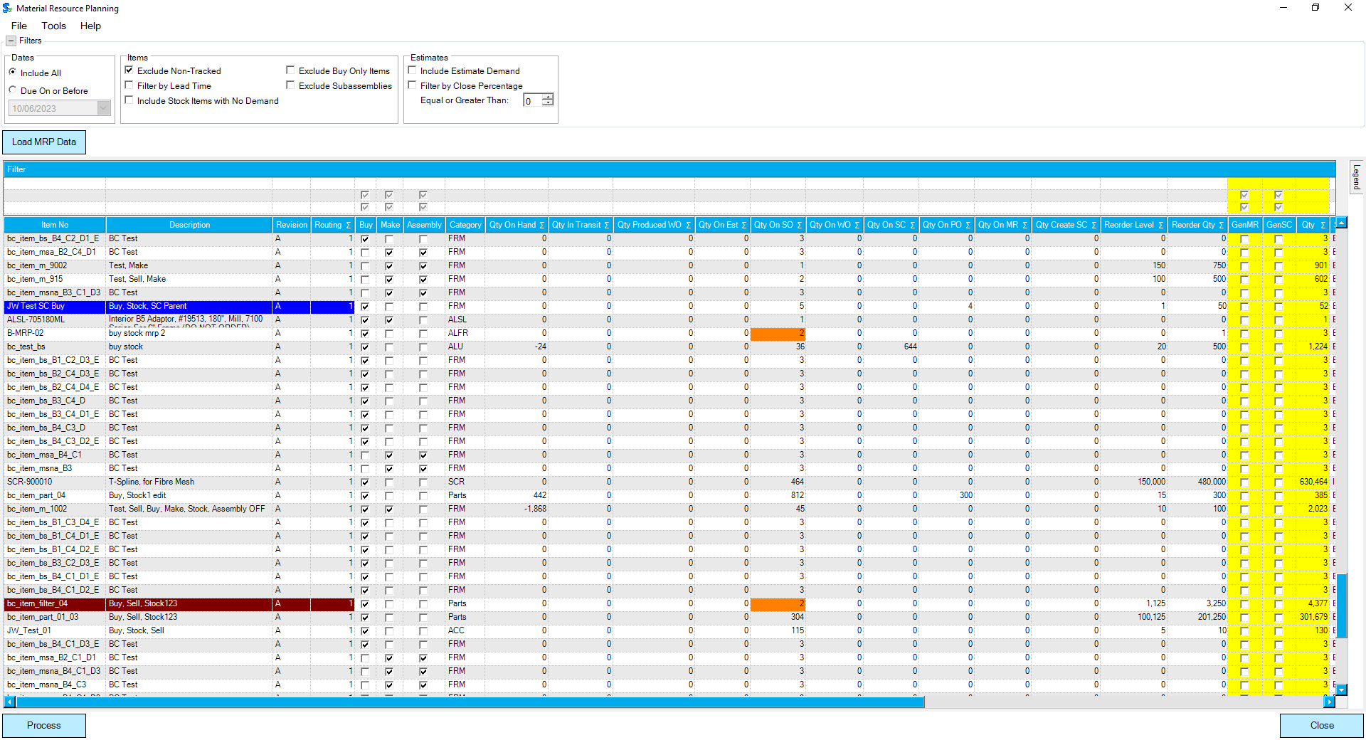
Component 1 – Demand Assessment and Selections
- From this newly remade version of the MRP form, users will be able to work with all stock items, whether make or buy. This will create the opportunity to filter, sort, and group by custom columns, dates, etc. From that selection process, the quantity to make/buy will be decided.
  - Making the recommended quantity requires only selection of the row.
  - Changing the qty allows for making/buying more or less. If a lesser qty is set, the remaining qty will appear still needed on next reload. This allows for splitting between make and buy when required.
- Exclusion of buy-only items lets the user populate the form with items that can be made or bought.
- Setting a fence before load will limit the visibility of demand to only the desired future demand dates.
- Excluding Subassemblies further limits data so that subassemblies can be later assessed based on recently processed and newer requirements.

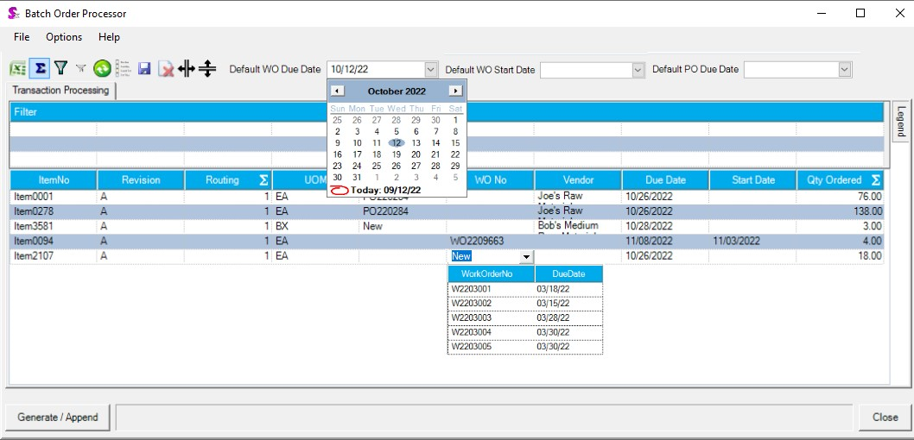
Component 2 – Document Generation
- When the Process button is clicked in the first form, this new custom form will open for generation of POs and Work Orders from the selected rows on the initial form.
- This form allows for deciding whether to generate a Work Order or Purchase Order for a given item.
  - Adding to an existing PO or Work Order is supported.
  - Generating new transactions is supported.
  - Settings for generation of a single Work Order of all included lines or for generation of a single Work Order per line will be included.
- Setting of PO Due Dates, Work Order Due Dates, and Work Order Start Dates is included.
  - The Start and Due Date fields will not allow for starting of Work Order or setting of PO or WO due dates when those dates are set as non-working days in the Main calendar.
- Processing these lines will generate or add to all Work Orders and POs as determined here.
- The grouped transactions will have a relationship to a new transaction type relevant to this batch. The purpose of this transaction is to allow for printing all Work Order and PO paperwork at one time for this batch of documents.

Additional Custom Logic
A separate ticket exists for the automatic serialization of Work Order lines, once the above process runs. This will adhere to Golden’s smart serialization rules, and is defined under a separate design.

